Measurement

Measurement介绍
Measurement包括频率响应函数、谐波分析、方波测量、1/3倍频程分析。

FrequencyResponseFunction

FrequencyResponseFunction介绍
提供获取系统幅度响应和相位响应函数；
①幅度响应：double[] GetMagenitude(double[] inputWaveform, double[] outputWaveform, bool inDB, AverageParam Average)

②相位响应：double[] GetPhase(double[] inputWaveform, double[] outputWaveform,bool inDegree,AverageParam Average)

其中inputWaveform为输入系统的信号，outputWaveform为inputWaveform经过系统后的信号，inDB/inDegree为真表示系统响应用dB表示，Average表示平均参数

范例
/***********************
* 带噪声的双频信号通过FIR滤波器后的得到单频信号
* 通过单频信号和双频信号求滤波器的频谱响应
* FIR LPF
* passFreq=50Hz
* stopFreq=100Hz
* 带外衰减40db
* 采样频率1000Hz
* ************************/
double Fs = 1000;
int freqLines = 500; //set frequency resolution here
double df = Fs / 2 / freqLines;
double[] coe = new double[] { 0.00194150175769345, -0.00169793575520208, -0.00426956799325628, -0.00829350380976647, -0.0132303432212115, -0.0181544335557185, -0.0217585679131809, -0.0225134101549763, -0.0189478446411358, -0.00995128109977753, 0.00489205937905203, 0.0250974062726473, 0.0492006450550267, 0.0748863114260257, 0.0992878499995790, 0.119424371366942, 0.132695897659600, 0.137328720011526, 0.132695897659600, 0.119424371366942, 0.0992878499995790, 0.0748863114260257, 0.0492006450550267, 0.0250974062726473, 0.00489205937905203, -0.00995128109977753, -0.0189478446411358, -0.0225134101549763, -0.0217585679131809, -0.0181544335557185, -0.0132303432212115 - 0.00829350380976647, -0.00426956799325628, -0.00169793575520208, 0.00194150175769345 };
double[] sinWave1 = new double[1000];
double[] sinWave2 = new double[1000];
double[] noise = new double[1000];
JY.DSP.Fundamental.Generation.SineWave(ref sinWave1, 1, 0, 10, Fs);
JY.DSP.Fundamental.Generation.SineWave(ref sinWave2, 1, 0, 120, Fs);
ArrayCalculation.Add(sinWave1, sinWave2, ref sinWave1);
JY.DSP.Fundamental.Generation.UniformWhiteNoise(ref noise, 0.01);
ArrayCalculation.Add(sinWave1, noise, ref sinWave1);
double[] sinWaveFir = new double[1000];
var fir = new FIRFilter();
fir.Coefficients = coe;
fir.Filter(sinWave1, ref sinWaveFir);
AnalogWaveformChart.Plot("input waveform", sinWave1);
AnalogWaveformChart.Plot("output waveform", sinWaveFir);

double[] bodeMag = new double[freqLines];
double[] bodePhase = new double[freqLines];
int numOfAverage = (int)Math.Floor((decimal)(sinWave1.Length / 2 / freqLines));
AverageParam Average = new AverageParam();
Average.Mode = AverageMode.RMS;
Average.Number = numOfAverage;
bodeMag = Measurement.FrequencyResponseFunction.GetMagenitude(sinWave1, sinWaveFir,true, Average);
bodePhase = Measurement.FrequencyResponseFunction.GetPhase(sinWave1, sinWaveFir, true, Average);
AnalogWaveformChart.Plot("BodeMagnitude", 0, 1 / df, bodeMag);
AnalogWaveformChart.Plot("BodePhase", 0, 1 / df, bodePhase);结果：
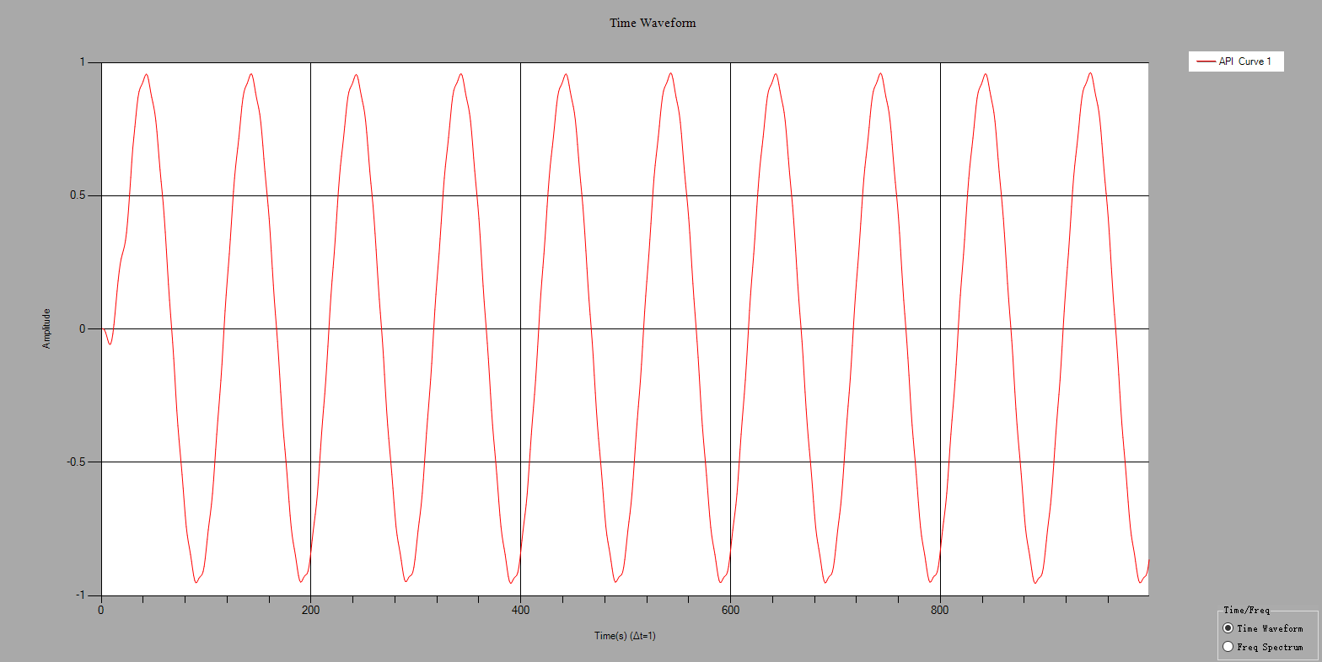
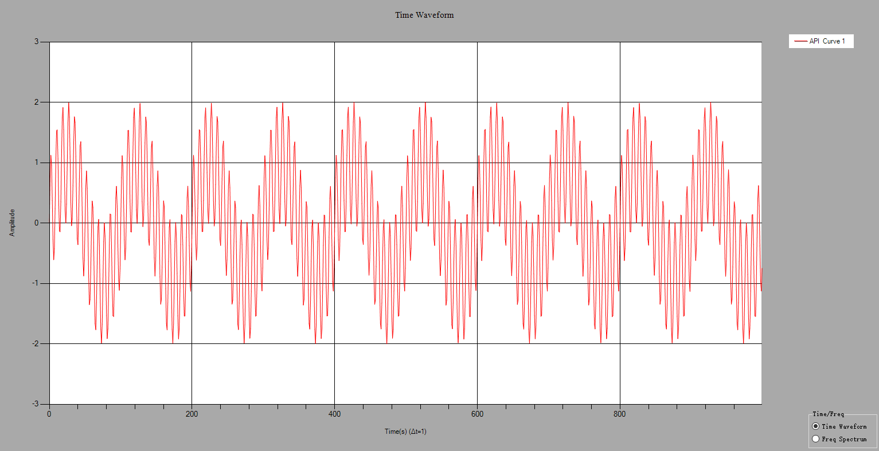
图 1.1系统的输入输出信号
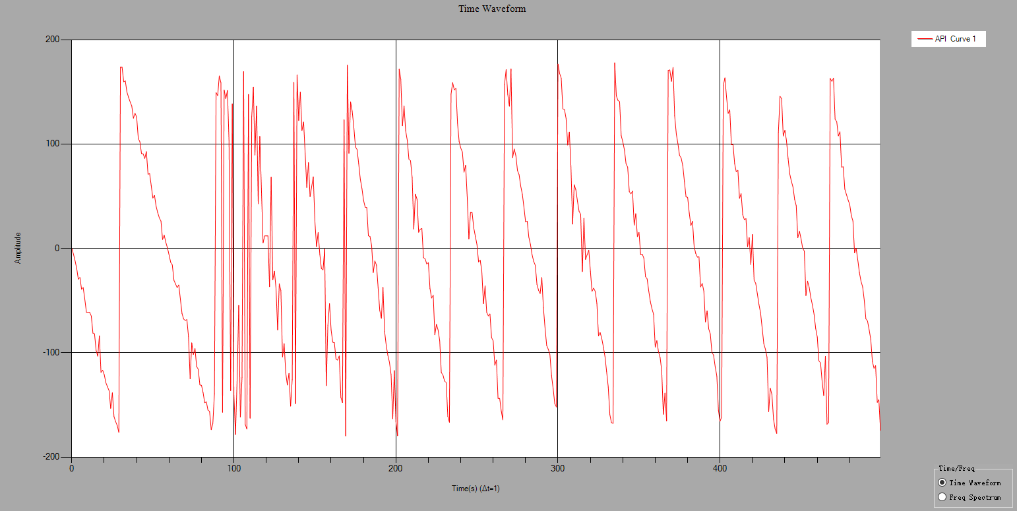
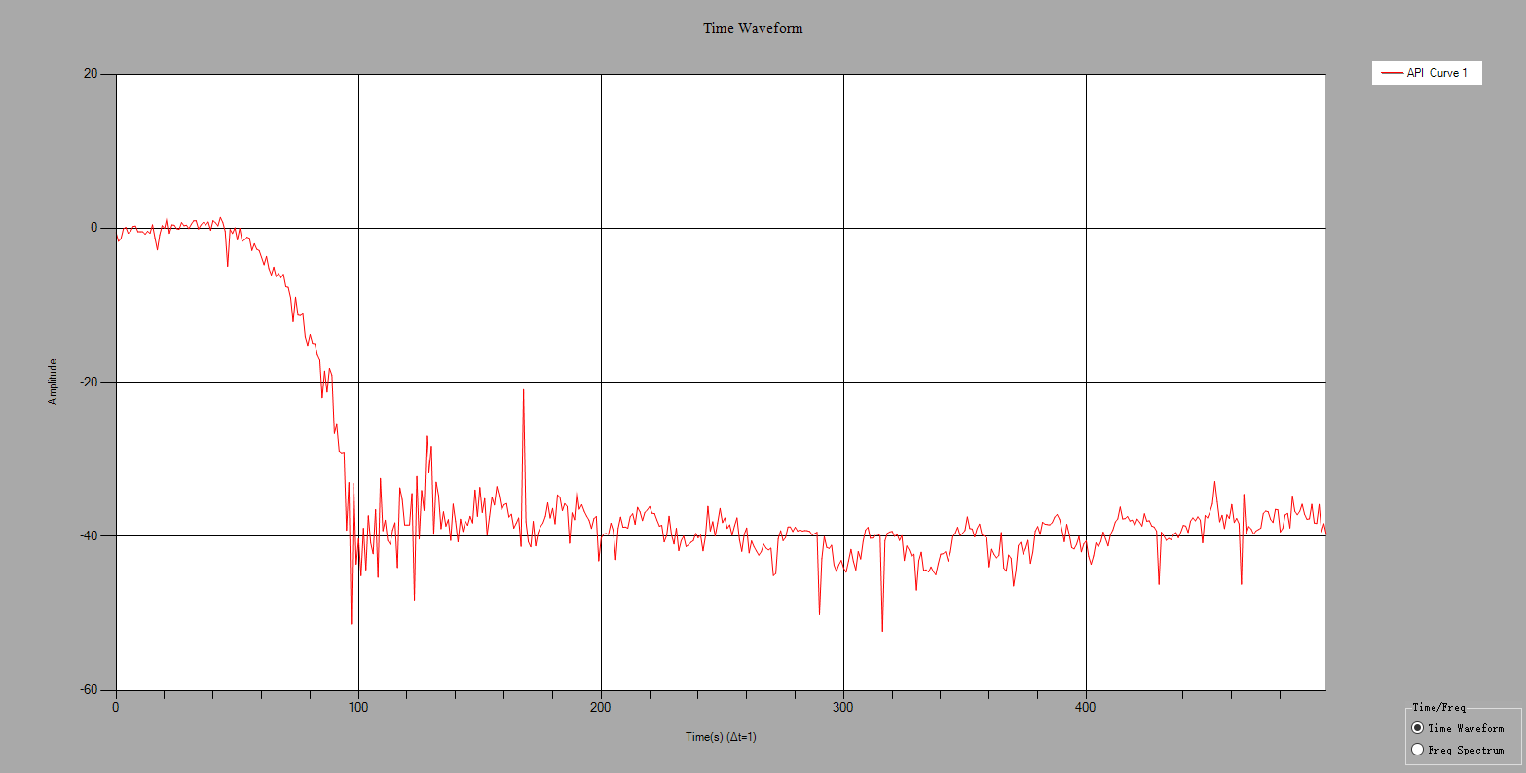
图 1.2系统的幅度响应和相位响应

HarmonicAnalysis

HarmonicAnalysis介绍
谐波分析包括ToneAnalysis、THDAnalysis、SINADAnalysis。
①ToneAnalysis：计算正弦波的幅值、频率和相位。
②THDAnalysis：分析谐波失真。
③SINADAnalysis：分析信纳比。

范例
/*************************************
* Tone分析 计算信号基波的幅度、相位、频率
* 基波频率为20
* ************************************/
var samplingRate = 1000;
var signalFrequency = 20;
var noiseLevel = 0.2;
var noise = new double[1000];
var signal = new double[1000];
JY.DSP.Fundamental.Generation.SineWave(ref signal, 4, 50, (double)signalFrequency, (double)samplingRate);
ArrayCalculation.AddOffset(ref signal, 2);
var dt = 1 / (double)samplingRate;
JY.DSP.Fundamental.Generation.UniformWhiteNoise(ref noise, noiseLevel);
ArrayCalculation.Add(signal, noise, ref signal);
AnalogWaveformChart.Plot("raw signal", signal);
double fundamentalFreq;
double phase;
double amplitude;
HarmonicAnalysis.ToneAnalysis(signal, dt, out fundamentalFreq,out amplitude,out phase);
Console.WriteLine("fundamentalFrequency={0}", fundamentalFreq);
Console.WriteLine("amplitude={0}", amplitude);
Console.WriteLine("phase={0}", phase);
结果：
fundamentalFreq=19.999813199835433
amplitude=3.9963377884507003
phase=50.079892166637848

/*************************************
* THD分析
* 基波频率为60
* ************************************/
var samplingRate = 1000;
var signalFrequency = 60;
var noiseLevel = 0.2;
var noise = new double[1000];
var signal = new double[1000];
JY.DSP.Fundamental.Generation.SineWave(ref signal, 1, 50, (double)signalFrequency, (double)samplingRate);
ArrayCalculation.AddOffset(ref signal, 2);
var dt = 1 / (double)samplingRate;
JY.DSP.Fundamental.Generation.UniformWhiteNoise(ref noise, noiseLevel);
ArrayCalculation.Add(signal, noise, ref signal);
AnalogWaveformChart.Plot("raw signal", signal);
double fundamentalFreq;
double THD;
double[] componentsLevel = new double[0];
HarmonicAnalysis.THDAnalysis(signal, dt, out fundamentalFreq, out THD, ref componentsLevel);
Console.WriteLine("fundamentalFrequency={0}", fundamentalFreq);
Console.WriteLine("THD={0}", THD);
AnalogWaveformChart.Plot("Analysis", componentsLevel);
结果：
fundamentalFreq=60.0043143232529
THD=0.0362533770383877

/*************************************
* SINAD分析
* 基波频率为60
* ************************************/
var samplingRate = 1000;
var signalFrequency = 60;
var noiseLevel = 0.2;
var noise = new double[1000];
var signal = new double[1000];
JY.DSP.Fundamental.Generation.SineWave(ref signal, 1, 50, (double)signalFrequency, (double)samplingRate);
ArrayCalculation.AddOffset(ref signal, 2);
var dt = 1 / (double)samplingRate;
JY.DSP.Fundamental.Generation.UniformWhiteNoise(ref noise, noiseLevel);
ArrayCalculation.Add(signal, noise, ref signal);
AnalogWaveformChart.Plot("raw signal", signal);
double fundamentalFreq;
double SINAD;
double[] componentsLevel = new double[0];
HarmonicAnalysis.SINADAnalysis( signal, dt, out fundamentalFreq, out SINAD, ref componentsLevel);
Console.WriteLine("fundamentalFrequency={0}", fundamentalFreq);
Console.WriteLine("SINAD={0}", SINAD);
AnalogWaveformChart.Plot("Analysis", componentsLevel);

结果：
fundamentalFreq=59.996122423727464
SINAD=1.0601596233046509

SquarewaveMeasurements

SquarewaveMeasurements介绍
方波测量包括幅值分析、周期分析、相位分析、电平直方图和占空比直方图
①幅值分析：void AmplitudeAnalysis(double[] waveform, out double highLevel, out double lowLevel)
②周期分析：void PeriodAnalysis(double[] waveform, out double period, out double dutyCycleAvg,out double pulseCount, out double pulseMaxWidth, out double pulseMinWidth)
③相位分析void PhaseAnalysis(double[] waveform, double[] waveformRef,out double phase)
④电平直方图：bool GetLevelHistogram(ref double[] histogramX, ref double[] histogramY, Histogram histogramConfig)
⑤占空比直方图：bool GetDutyCycleHistogram(ref double[] histogramX,ref double[] histogramY,Histogram histogramConfig)
其中waveform为方波信号，waveformRef为参考方波信号，highLevel为高电平，lowLevel为低电平，period为周期（单位为采样点），dutyCycleAvg为占空比（0~1），pulseCount位脉冲数，pulseMaxWidth为最大脉宽（单位为采样点），pulseMinWidth为最小脉宽（单位为采样点），phase为waveform相对于waveformRef为相位。

范例
/**************************
* 产生频率为20Hz，采样率为1000Hz，幅值为2V，占空比为50%的方波
* 测量方波的高电平、低电平、周期、相位
* ***************************/

double[] waveformTmp = new double[1000];
double[] waveformRef = new double[1000];
JY.DSP.Fundamental.Generation.SquareWave(ref waveformTmp, 2, 50, 20, 1000);
JY.DSP.Fundamental.Generation.SquareWave(ref waveformRef, 2, 50, 20, 1000);
double highLevel;
double lowLevel;
double period;
double dutycycle;
double phase;
double pulseCount;
double pulseMaxLength;
double pulseMinLength;
SquarewaveMeasurements.AmplitudeAnalysis(waveformTmp, out highLevel, out lowLevel);
SquarewaveMeasurements.PeriodAnalysis(waveformTmp, out period, out dutycycle,
out pulseCount, out pulseMaxLength, out pulseMinLength);
SquarewaveMeasurements.PhaseAnalysis(waveformTmp, waveformRef, out phase);
double[] levelHistogramX = new double[0];
double[] levelHistogramY = new double[0];
SquarewaveMeasurements.GetLevelHistogram(waveformTmp,ref levelHistogramX, ref levelHistogramY, new SquarewaveMeasurements.Histogram());
for (int j = 0; j < levelHistogramX.Length; j++)
{
Console.WriteLine("{0}:{1}", levelHistogramX[j], levelHistogramY[j]);
}
Console.WriteLine("highLevel:{0}", highLevel);
Console.WriteLine("lowLevel:{0}", lowLevel);
Console.WriteLine("period:{0}", period);
Console.WriteLine("phase:{0}", phase);
结果：
highLevel=2
lowLevel=-2
period=50
phase=0

ThirdOctaveAnalysis

ThirdOctaveAnalysis介绍
1/3倍频程分析

范例
/*****************************
* 产生50Hz的正弦信号
* 做1/3倍频程分析
* 时间平均方式为Fast
* 加权滤波器的类型为A加权
* 中心频率为50即第4频段（从0开始）的能量最高
* ******************************/
double duration = 2; //seconds;
double sampleRate = 51200; //you cannot change this
int dataLength = (int)(duration * sampleRate);
double[] sin1 = new double[dataLength];
JY.DSP.Fundamental.Generation.SineWave(ref sin1, 1.414, 0, 50, sampleRate);
ThirdOctaveAnalysis analysis = new ThirdOctaveAnalysis();
analysis.AverageMode = Conditioning.TimeAveragingMode.Fast;
analysis.WeightingFilterType = WeightingType.AWeighting;
var result = analysis.Analyze(sin1, sampleRate);
double[] octaveLevels = new double[result.ThirdOctaveLevels.Length];
for (int i = 0; i < octaveLevels.Length; i++)
{
octaveLevels[i] = 20 * Math.Log10(result.ThirdOctaveLevels[i]) + 100;
}
AnalogWaveformChart.Plot("Mode=Fast and WeightingFilterType=AWeighting", octaveLevels);
结果:
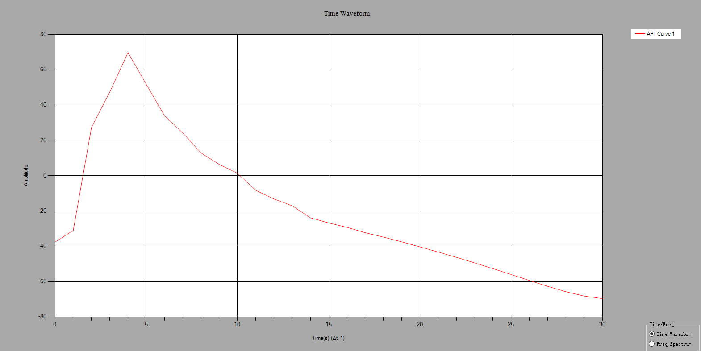
图 1.3 1/3倍频程分析

